University of Wollongong
CSIT305: Emerging Information Technologies and their Applications

ASSESSMENT COVER SHEET
Student Name | Student Number | Tutorial
Joseph Koh (Leader) | 1441309 | T01
Suzaina | 1037195 | T01
Khin Kan Kaw Lin |  | T01

Tutor name: Prof. Jun Yan
Assessment: Group Project

STUDENTS DECLARATION
I declare that this assessment is entirely my own work and has not been submitted for assessment in any other subject or course. This work complies with the University of Wollongong's Academic Integrity Policy.
Signature:
Date:
Team Contribution
Student Name | Workload
Joseph (Leader) | System Overview  - Introduction, System Goal, Stakeholders, Existing solution and Comparison  Function 1 (AI-Based Flood Prediction & Risk Analysis)  - Introduction, Multi-Modal Database, Software Architecture, Networking
Khin Kan Kaw Lin | Function 2 (

Table of contents here…

Introduction
Singapore has a tropical climate and receives frequent rainfall of approximately 2000 - 2500mm annually. As a highly urbanised city, much of its land is covered by impermeable surfaces such as roads, buildings, and concrete pavements. These surfaces prevent rainfall from infiltrating into the ground, increasing surface runoff during periods of heavy rainfall. Large volumes of runoff can overwhelm drainage systems and waterways resulting in flash floods in densely developed areas (CBD).
A recent study found that nearly all 108 urban flooding events recorded in Singapore between 2017 and 2023 were associated with short duration, high intensity rainfall, which overwhelmed drainage systems and resulted in flash floods (Lommen et al., 2025).
Therefore, FloodWatch is proposed as a smart flood management system by team Mag4 to mitigate the ever increasing risk of flash flooding in Singapore. The system leverages on emerging information technologies and its applications to improve and enhance the current flood management system in Singapore.
System Goal
The primary goal of FloodWatch is to rearchitect the current existing flash flood management system infrastructure in Singapore by transforming it from a reactive approach to a proactive and preventive approach. The system harnesses emerging cutting-edge technologies such as IoT devices, advanced databases, next generation networking infrastructure, predictive AI machine learning models and modern cloud platforms to enable real-time monitoring, analysis, and decision making. By providing accurate and timely information, FloodWatch enables stakeholders and the public to make quick informed decisions, strengthen emergency preparedness and improve public safety.
Stakeholders
Users / Agencies | Role | Use case
Public Utilities Board (PUB) | System User | Primary user of FloodWatch to monitor real-time data and predictive analysis
National Environmental Agency (NEA) | Data Provider | Primary data provider who provides real-time and historical weather and rainfall data
Meteorological Service Singapore (MSS) (under NEA) | System Operator | Operates weather radar systems to produce rainfall forecasts, heavy rain warnings, and storm predictions
Singapore Civil Defence Force (SCDF) | Rescue Operator | Conducts evacuations and rescue operations on severe flooding events
Land Transport Authority (LTA) | Infrastructure Manager | Manages traffic closure and diversion in flood affected areas
Certis CISCO under Singapore Police Force (SPF) | Traffic Police | Assists in traffic control and public safety in flood affected areas
Town Councils | Estate Manager | Maintain estate drainage systems in residential areas

Existing Solutions & Comparison
Singapore’s flood management system is managed by multiple government agencies with the Public Utilities Board (PUB) as the lead agency.
Figure 1 illustrates a high level overview of Singapore’s current flood management system and the coordination between key stakeholders.
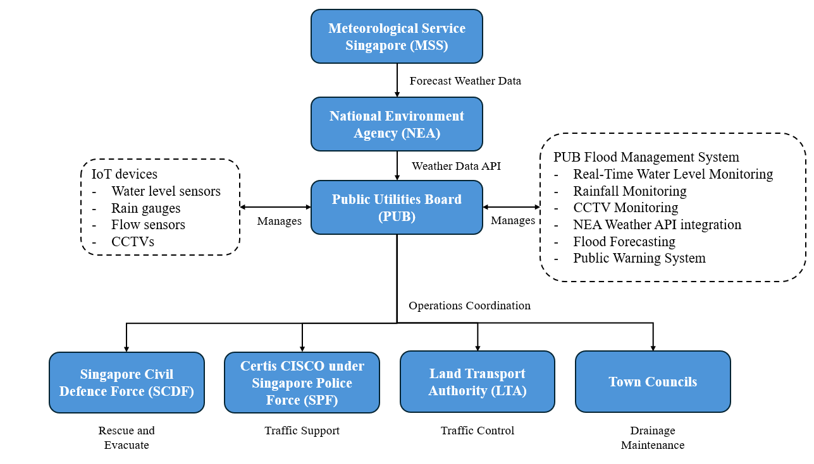Figure 1. High-level overview of Singapore's existing flood management system (author's illustration, adapted from PUB, 2025).
PUB’s current flood management system primarily focuses on real-time monitoring, forecasting, and issuing warnings, with the primary goal of detecting floods quickly and alerting the public (Reactive Response Model).
Figure 2 illustrates a high level process overview of how PUB manages the flood management system.
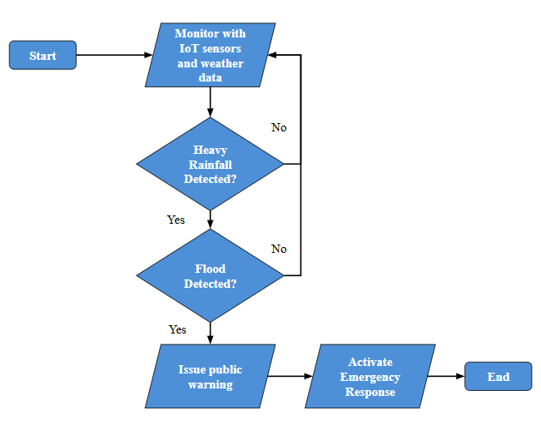Figure 2. High-level flow diagram of Singapore's existing flood management system (author's illustration, adapted from PUB, 2025).
Although the current system provides real-time monitoring, it relies on monitoring existing conditions rather than predicting flash flood risks before they occur. This reactive approach motivates the development of FloodWatch, which integrates predictive AI, (add your functions) to enable proactive flood management.
Figure 3 illustrates a high level process overview of FloodWatch
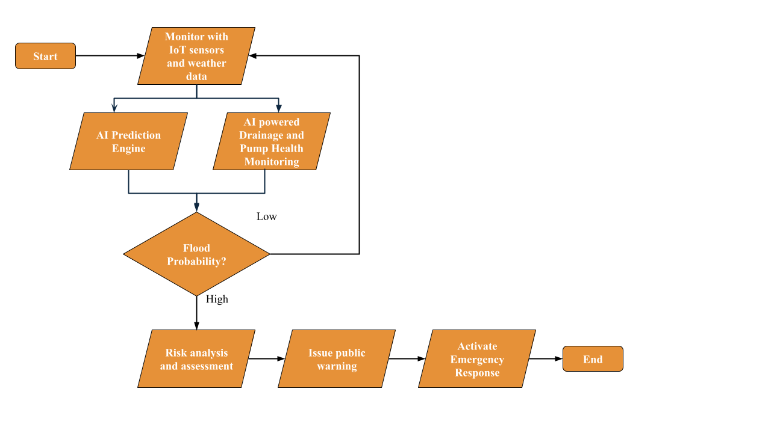Figure 3. High-level flow diagram of FloodWatch
FloodWatch restructures the existing approach by adopting an Anticipatory Preventive Model that leverages predictive analytics, risk assessment, (add your functions) to identify potential flooding in advance, enabling proactive interventions, informed decision making, and preventive measures that enhances overall flood resilience.
Key Functions
The key functions of FloodWatch are as follows:
1. AI-Based Flood Prediction & Risk Analysis
2. AI-Powered Drainage & Pump Health Monitoring

3.

…

1. AI-Based Flood Prediction & Risk Analysis
The purpose of this function is to predict flood events and perform impact analysis before flooding occurs. Unlike conventional flood management systems which alert stakeholders after flooding has already begun, this function alerts stakeholders of flood probabilities well in advance giving response teams sufficient time to implement preventive measures, coordinate emergency operations and also execute damage control increasing overall efficiency of flood management.

Real-time environmental data is continuously collected from IoT devices deployed across Singapore such as water level sensors, rain gauges, flow sensors, CCTV cameras and weather forecast APIs. The collected data is transmitted through an IoT gateway to a cloud platform where it is stored in multiple noSQL databases. Using real-time streaming processing, the data is analysed by AI based supervised machine learning models that combine live sensor readings, weather forecasts and historical records to predict flood probability and estimate flood severity.

Additionally, this function also performs detailed flood impact analysis on the predicted high risk areas. This is achieved by representing the predicted flood as a geospatial flood map which is overlaid with Geographic Information System (GIS) layers containing information on MRT stations, roads, buildings and drainage networks. By performing spatial analysis, the system then identifies assets that are likely to be affected, estimates disruption levels and generates actionable suggestions such as alternative travel routes, temporary road closure or emergency response team deployment.

This enables stakeholders to make informed, data-driven decisions before flooding occurs, reducing risks to infrastructure and the public.

1.2 Multi Modal Database
1.2.1 Dataset Storage
S/N | Data | Update Frequency | Data Source | Data Destination | Database Type
1 | 2-Hour Weather Forecast | Every 30 mins | NEA REST API | AWS RDS Postgres SQL | SQL
2 | 2-Hour Weather Forecast | Every 30 mins | NEA REST API | AWS ElastiCache (Redis) | NoSQL (Cache)
3 | Water Level Sensor, Flow Sensor, Rain Sensor | Real-Time | IoT Devices (Sensors) | AWS Timestream | Time-Series DB
4 | Sensor Location | Static (On Registration) | IoT Devices (Sensors) | AWS RDS PostgreSQL + PostGIS | Spatial DB
5 | GIS Data (Buildings, Roads, Rivers, Flood Zones) | As Required | GIS Dataset | AWS RDS PostgreSQL + PostGIS | Spatial DB
6 | Flood Prediction Report and Incident Report | Event-driven | AI Prediction Engine | AWS DynamoDB | Document DB

There are 4 types of data:
- NEA REST API Data
- Live IoT Sensor Readings and Location Data
- GIS Data
- AI Prediction Engine Data
NEA REST API Data
2 datasets containing 2-hour weather forecast data will be retrieved from NEA REST API, with each dataset serving a different purpose.
- AWS ElastiCache (Redis): Each data retrieval replaces the previous record, keeping only the latest snapshot of the weather forecast. This enables fast access for the AI prediction engine which answers “what is the current weather?”
- AWS Postgres SQL: Each data retrieval inserts a new record keeping a historical archive of weather forecast snapshots. This supports historical data analysis, trend detection, model training, reporting and also auditing.
Below illustrates an example of data stored in AWS ElastiCache (Redis) and AWS Postgres SQL:
AWS ElastiCache (Redis):
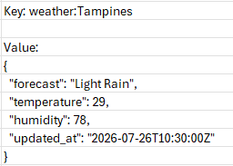
AWS Postgres SQL:
Live IoT Sensor Readings and Location Data
Various types of IoT Sensor devices will be deployed across Singapore:
- Water Level Sensor
  - Measures the height level of water in canals, drains and reservoir
- Flow Sensor
  - Measures the water velocity in canals, drains, rivers and reservoir
- Rain Gauge Sensor
  - Measures the amount and intensity of rainfall
Each sensor periodically transmits readings at 1-minute intervals which are ingested into AWS Timestream (Time-Series DB). Each reading is stored as a timestamped record, providing a real-time time-series dataset for the AI prediction engine.
Below illustrates an example of real-time sensor readings stored in AWS Timestream:
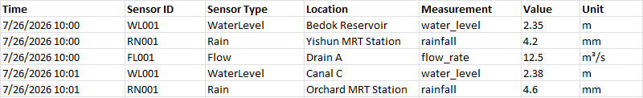
IoT sensors’ location data are stored in AWS RDS PostgreSQL with PostGIS extension enabled. PostGIS supports storing geometry objects in addition to normal relational data. A geometry object in PostGIS is a set of coordinates that define the shape and location of a geographic feature:
- POINT()
  - IoT sensor devices’ location are stored as POINT geometries
- Polygon()
  - Buildings and flood zones are stored as Polygon geometries
- LineString()
  - Roads and rivers are stored as LineString geometries
Below illustrates an example of IoT sensors’ location stored in AWS RDS PostgreSQL+ PostGIS extension:
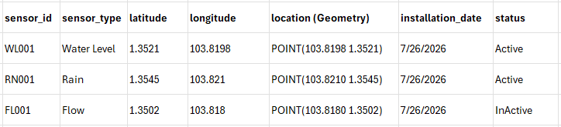
GIS Data
GIS datasets are stored as separate spatial tables depending on their geometry type. This dataset is crucial as it serves as the Source of Truth (SOT) for GIS overlay analysis. However, the GIS database must first be populated with spatial data before it can perform spatial queries. The master data is provided by Government GIS datasets, OpenStreetMap (OSM) or Google Maps Platform APIs.
Below illustrates an example of geometry objects stored in AWS RDS PostgreSQL+ PostGIS extension:
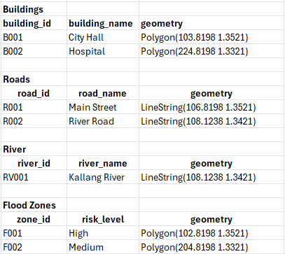
AI Prediction Engine Data
The AI prediction model will predict flood probabilities and severity level using real time data collected from IoT sensors and weather forecast data obtained from NEA Weather Forecast API. It generates flood prediction and impact analysis reports and stores them into AWS Dynamo DB, a NoSQL key-value and document database. Each report is stored as a document containing key-value pair attributes.
The generated reports are subsequently transmitted to downstream agencies, including the Singapore Police Force (SPF), Singapore Civil Defence Force (SCDF), and Town Councils, via REST APIs. This enables stakeholders to receive timely situational awareness, support informed decision-making, improve emergency preparedness, and coordinate response efforts to enhance public safety.
Below illustrates an example of document objects stored in AWS Dynamo DB:
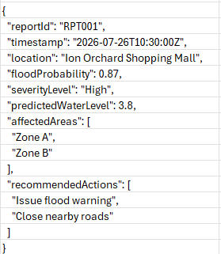
1.2.2 Dataset Query Processing
Data stored are queried to retrieve information for analysis and decision making. Different types of data require different query languages, depending on the type of database in which they are stored.
Weather Forecast Query
2-Hour Weather Forecast Data retrieved from NEA REST API stored in AWS ElastiCache (Redis) are queried using Redis Command Language (RESP protocol). Every record inserted is automatically indexed making lookups extremely fast. The data queried provides current weather conditions for AI prediction.
Example query: Latest 2-hour weather forecast for Tampines, Pasir Ris, Jurong East, Woodlands
Historical Weather Forecast Query
2-Hour Weather Forecast Data retrieved from NEA REST API stored in AWS RDS PostgreSQL are queried using SQL language. Indexing scripts are executed during creation of relational tables to enable fast lookup. The data queried provides historical weather records for data analysis, trend detection, model training, reporting and also auditing.
Example query: 2-hour weather forecast records for the last 5 years
Time-Series Query (IoT Devices)
Real-time water level, flow rate and rainfall intensity data retrieved from sensor devices stored in AWS Timestream are queried using SQL language as it supports SQL syntax. However, unlike traditional relational databases, records inserted are automatically indexed. The data queried provides real-time flood monitoring and early flood prediction.
Example query: Current water level, rainfall intensity and flow rate readings
GIS Spatial Query (IoT Device Location)
IoT sensors’ location data are stored in AWS RDS PostgreSQL with PostGIS extension enabled area queried using SQL language. With PostGIS extension enabled, it supports storing geometry objects in addition to normal relational data. Spatial indexes (GiST Generalized Search Tree) are created during creation of relational tables. This helps to avoid scanning every sensor when using queries like nearest-neighbour to ensure fast lookup. The data queried provides sensor location within a certain distance of a predicted flood.
Example query: All sensors closest to the predicted flood location of Newton MRT station
AI Prediction Query
Data from weather forecasts, live sensor readings and historical data are feeded to the AI prediction engine to generate flood predictions. It is the core function of proactive flood prediction and risk analysis.
Example query: List all predicted flood probability and severity
GIS Spatial Query (Mapping Overlay)
When the AI prediction engine flags all predicted flood locations, it sends flood location objects (polygons) to the GIS database for spatial querying. PostgreSQL with PostGIS then performs spatial overlay analysis to identify roads, buildings, and other infrastructure that intersect the predicted flood location. This enables flood impact assessment and damage control.
Example query: All infrastructures that intersect the predicted flood area of Newton MRT station
Document Query
Flood prediction reports generated by the AI prediction engine are stored in AWS DynamoDB. These reports are distributed to downstream agencies, such as SCDF, SPF, and Town Councils to support situational awareness and emergency response The reports can also be retrieved for auditing, reporting, and survey purposes.
Example query: All flood prediction reports for Bugis generated within the last 2 weeks
Analytics Features
S/N | Analytics Type | Purpose | Data Source
1 | Historical | Historical weather conditions for data analysis, trend detection, model training, reporting and also auditing. | NEA REST API data
2 | Descriptive | Monitors current weather conditions, rainfall, water level and flow rate across Singapore. | NEA REST API data, IoT Devices (Sensors)
3 | Predictive | Forecasts flood probability and severity using AI prediction models. | NEA REST API data, IoT Devices (Sensors), GIS Dataset
4 | Spatial | Map surrounding infrastructure that overlay with predicted flood location to perform impact analysis and damage control. | AI Prediction Engine, GIS Dataset
5 | Prescriptive | Recommends response actions based on predicted flood impact such as alternative road routes, road closure and public warning. | AI Prediction Engine

1.3 Software Engineering
Below illustrates the architectural diagram for this function (AI-Based Flood Prediction & Risk Analysis)
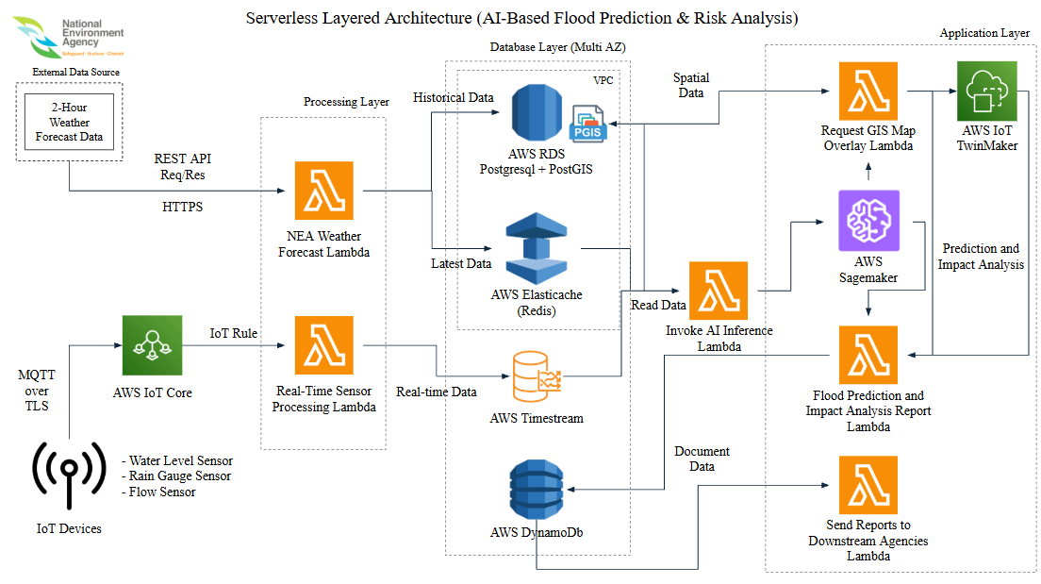Figure 5. Architectural Diagram for AI-Based Flood Prediction & Risk Analysis
This function (AI-Based Flood Prediction & Risk Analysis) adopts a serverless layered architecture hosted and deployed in AWS Cloud Ecosystem.
- Serverless (No hosting of servers (EC2), AWS manages the servers)
- Layered (Divide systems into separate layers with separate responsibilities)
Data Source
There are 2 main types of data sources:
- NEA Weather Forecast Data
- IoT Sensor Readings Data
The NEA weather forecast data is transmitted from NEA’s endpoint to FloodWatch’s endpoint via a (Representational State Transfer) REST API. To establish successful data transmission, the NEA’s endpoint IP address must first be whitelisted as FloodWatch endpoint only accepts connections from authorised IP addresses.
The IoT sensor readings data are authenticated and verified by AWS IoT Core, a service that securely manages communication with IoT devices before the data is transmitted to the processing layer.
Processing Layer
In the processing layer, AWS Lambda processes the incoming NEA weather forecast data and IoT sensor readings by validating them before they are ingested into the databases.
- AWS Lambda is a serverless function that executes code when triggered by an event
- Data Transformation is the process of cleaning and restructuring data to a suitable format before data insertion to databases
- Data Ingestion is the process of importing data from source to destination
Database Layer
The database layer is responsible for storing, managing and retrieving processed data for analysis, reporting, AI model training and prediction. Multi-Available Zone (AZ) is enabled to ensure AWS performs automatic failover to the standby AZ should the primary AZ fail. This helps reduce risks of downtime.
Multiple databases are used for this function:
S/N | Data | Database | Database Type
1 | 2-Hour Weather Forecast | AWS RDS Postgres SQL | SQL
2 | 2-Hour Weather Forecast | AWS ElastiCache (Redis) | NoSQL (Cache)
3 | Water Level Sensor, Flow Sensor, Rain Sensor | AWS Timestream | Time-Series DB
4 | Sensor Location | AWS RDS PostgreSQL + PostGIS | Spatial DB
5 | GIS Data (Buildings, Roads, Rivers, Flood Zones) | AWS RDS PostgreSQL + PostGIS | Spatial DB
6 | Flood Prediction Report and Incident Report | AWS DynamoDB | Document DB

Application Layer
Each time new sensor readings or updated NEA weather forecast data have been processed and stored in their respective databases, the corresponding processing Lambda function invokes the AI Inference Lambda.
The AI Inference Lambda is responsible for retrieving the latest real-time sensor readings from Amazon Timestream, the latest weather forecast from Amazon ElastiCache (Redis), and historical flood and spatial data from Amazon RDS PostgreSQL. It then combines the raw data from different sources (Aggregation) and formats it into the input required by the ML model.
The prepared input is then sent to AWS SageMaker inference endpoint in the application layer where the AI ML model generates flood prediction and performs impact analysis. For each predicted flood event, the AI prediction engine identifies predicted flood locations and passes the data to the GIS Overlay Map Lambda.
The Request GIS Map Overlay Lambda queries the PostGIS database to retrieve spatial data and performs spatial overlay analysis by intersecting the predicted flood locations with roads, buildings, rivers, and other infrastructure. This identifies the infrastructure that is potentially affected by the predicted flood event.
The spatial analysis results are then passed to the Flood Prediction and Impact Analysis Report Lambda which generates a structured flood prediction and impact analysis report and stores it in Amazon DynamoDB.
Parallely, spatial analysis results are also passed to AWS IoT TwinMaker, which creates a digital twin of FloodWatch system. This provides PUB operators with a live, interactive visualization of Singapore's drainage network, real-time flood conditions, and AI-predicted flood hotspots, enabling faster situational awareness and more informed operational decision-making.
Finally, the Send Reports to Downstream Agencies Lambda retrieves the generated report from Amazon DynamoDB and distributes it to the relevant downstream agencies to support situational awareness, emergency response, and operational decision-making.
AI Application
The core functionality of this feature relies on the use of AI to predict flooding events. AWS SageMaker is a platform that provides AI models with the tools to build, train, tune, deploy and manage the entire AI workflow. The aggregated raw data prepared by the AI Inference Lambda is processed in AWS SageMaker where processing jobs, data wrangler and python libraries (NumPy) are used to clean and transform the data before it is passed to an AI model.
The AI models used are:
S/N | AI Model | Purpose
1 | Long Short-Term Memory (LSTM) | To predict future water levels
2 | Random Forest | To determine flood risk levels

Each AI model handles a different part of the prediction problem.

Long Short-Term Memory (LSTM)

LSTM is a type of Recurrent Neural Network (RNN) designed for learning and forecasting sequential (time-series) data. It is well suited for water level prediction as water levels are continuous real-time measurements that depend on historical observations and temporal patterns in water levels, rainfall, water flow and weather conditions.

The LSTM model uses both real-time data and historical data as inputs including:
- Historical water levels (Previous water level measurements
- Rainfall data (Current and past rainfall intensity)
- Water flow (Volume and speed of water flowing through rivers or drainage systems)
- Weather forecast (Predicted rainfall, temperature)

These variables serve as inputs to the LSTM model and which predicts the future water level as its output. It is then passed to the Random Forest model.

Random Forest

Random Forest is a machine learning classification algorithm that consists of multiple decision trees. Each decision tree independently makes a prediction and the Random Forest combines all the tree’s predictions using a majority voting mechanism to produce a final result. It is a classifier to determine flood risk levels by using predicted water levels from LSTM with other environmental variables to classify the flood risk into categories (Low, Moderate, High).

For example:
- If predicted water level < 2.5m (from LTSM), low rainfall and short duration → Low flood risk
- If predicted water level > 2.5m (from LTSM), low rainfall and short duration → Moderate flood risk
- If predicted water level > 2.5m (from LTSM), high rainfall and long duration → High flood risk

Below illustrates the workflow and classified dataset of Random Forest:
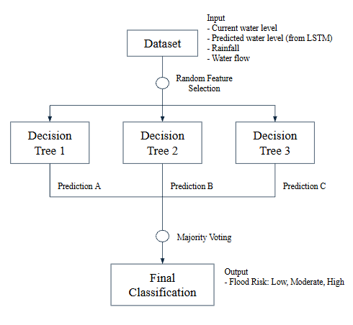

Current Water Level | Predicted Water Level (LSTM) | Rainfall | Duration | Flood Status
1.4m | 1.8m | 5mm | Short | Low
1.4m | 2.6m | 25mm | Short | Moderate
1.4m | 2.9m | 40mm | Long | High

Once the data is finalised and classified into a flood risk level (low, moderate, high), the Request GIS Overlay Lambda is invoked to retrieve and overlay GIS spatial data for the predicted impacted area.
In summary, LSTM and Random Forest work together to provide accurate and timely flood predictions:
- LSTM analyses historical and real-time time-series data to forecast future water levels
- Random Forest classifies the predicted flood severity based on multiple environmental variables
By combining both models, the system can proactively identify potential flood events, assess their severity, and support early warning and emergency response efforts.
1.4 Networking

Source | Destination | Communication  Protocol / Rule
NEA Weather Forecast | AWS Weather Forecast Lambda | HTTPS
IoT Devices | AWS IoT Core | MQTT + TLS
AWS IoT Core | AWS Real-Time Sensor Processing Lambda | IoT Rule

NEA Weather Forecast to AWS Weather Forecast Lambda
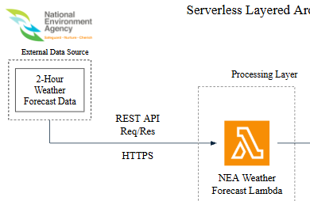

The NEA weather forecast data (payload) is transmitted from NEA’s endpoint to FloodWatch’s endpoint via a REST API
- Payload is the data sent between client and server
- An API (Application Programming Interface) is an interface that allows software applications to communicate with one another
- REST (Representational State Transfer) is an architectural style for designing web APIs with HTTP methods (GET, POST, PUT, DELETE)
The communication protocol used is HTTPS (HTTP + TLS)
- Hyper Text Transfer Protocol (HTTP) are used to exchange payload between client and server over a network
- Payloads exchanged over HTTP are unencrypted by default and can be intercepted or modified by a hacker. Hence, Transport Layer Security (TLS) are used to encrypt the payload before transmitting over the network
IoT Devices to AWS IoT Core
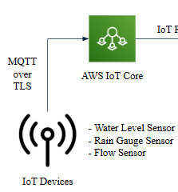

Real-time sensor data is transmitted from IoT devices to AWS IoT Core. IoT devices are water level sensor, flow sensor and rain gauge sensor. AWS IoT Core is a managed cloud service by AWS that acts as a MQTT broker that allows communication between IoT devices and AWS Cloud.
The communication protocol used is MQTT + TLS
- Message Queuing Telemetry Transport (MQTT) are used to send/receive data packets (messages) from IoT devices
- Data transmitted over MQTT are unencrypted by default and can be intercepted or modified by a hacker. Hence, Transport Layer Security (TLS) is used to encrypt the data before transmitting data to AWS IoT Core.
AWS IoT Core to AWS Real-Time Sensor Processing Lambda
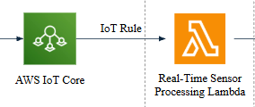

Once data is received by AWS IoT Core from IoT devices, it is evaluated against the configured IoT Rules before invoking AWS Real-Time Sensor Processing Lambda.
- If data does not match the criteria, the data is not forwarded to the lambda
- If data matches the criteria, the data is accepted and the processing lambda is invoked
Advanced Technologies and Security

Cross Origin Resource Sharing (CORS)
In order to establish successful data transmission, the NEA’s endpoint IP address must first be whitelisted. FloodWatch endpoint only accepts connections from authorised IP addresses preventing unknown sources from connecting to FloodWatch enhancing security of data exchange.
Transport Layer Security (TLS)
Formerly known as Secure Socket Layer (SSL) which is a security protocol that encrypts data exchanged between client and server.
Without TLS:
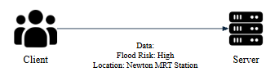
With TLS:
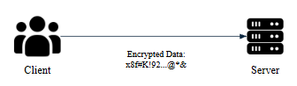
In this feature, the NEA Weather Forecast Lambda sends a HTTPS request connection to NEA Weather API, the NEA Server sends its TLS Certificate. The lambda verifies its origin to ensure it is issued by a trusted Certificate Authority (CA) and not expired and matches the NEA domain.
Once the certificate is successfully verified, the lambda and NEA establish a secure connection with a shared session key. NEA server encrypts the payload using the same session key and sends the payload to the lambda. Once the data transmission is completed, the TLS session is terminated.

- AI-Powered Drainage & Pump Health Monitoring
Description
The AI-Powered Drainage & Pump Health Monitoring function continuously monitors the operational condition of Singapore's drainage infrastructure to ensure that drains and pumping stations remain capable of handling heavy rainfall. The system detects drain blockages, estimates drainage capacity, predicts pump failures, and recommends preventive maintenance before infrastructure failures contribute to flash flooding.
Significance

Efficient drainage infrastructure plays a critical role in preventing flash floods. Even when rainfall intensity is manageable, blocked drains or malfunctioning pumps can significantly reduce drainage capacity, causing water to accumulate rapidly on roads and low-lying areas. By continuously monitoring infrastructure health and predicting failures before they occur, this function enables PUB to perform proactive maintenance, ensuring that drainage systems remain fully operational during heavy rainfall and improving the accuracy of flood risk predictions.

Usage of Emerging Technologies

1. IoT Sensing
The AI-Powered Drainage & Pump Health Monitoring function utilises a network of IoT sensors installed across Singapore's drainage infrastructure and pumping stations to continuously collect real-time operational data. Water level sensors monitor drainage water levels, flow sensors measure drainage capacity, while vibration, motor temperature, and electrical current sensors assess pump health and performance. AI-enabled CCTV cameras are also deployed to monitor drainage channels for debris accumulation and blockages. Sensor data is securely transmitted using the MQTT protocol to AWS IoT Core, enabling reliable real-time data collection from distributed infrastructure.

2. Data Processing
The collected sensor data and CCTV feeds are processed in real time using Amazon Kinesis, which ingests and streams continuous data from multiple monitoring locations. AWS Lambda performs data validation, filtering, and preprocessing before forwarding the cleaned data for further analysis. At the same time, YOLOv11 computer vision models analyse CCTV images to automatically detect blocked drains and debris accumulation, while historical maintenance records are combined with live sensor readings to provide additional context for anomaly detection and predictive analysis.

3. Cloud-Based Intelligence
The processed data is analysed by predictive AI models hosted on Amazon SageMaker, which estimate pump failure probability, evaluate drainage capacity, and identify infrastructure anomalies before they lead to flooding. Historical sensor data stored in Amazon Timestream and maintenance records stored in Amazon DocumentDB support continuous model training and long-term trend analysis. The analysis results are visualised through the FloodWatch Dashboard, where PUB maintenance teams receive real-time alerts and maintenance recommendations, enabling proactive inspection.

